**Amazon Managed Service Provider (MSP) Program**

The goal of the MSP Program is to [recognize AWS Partner Network (APN) Partners](https://aws.amazon.com/partners/msp/?partner-solutions-cards.sort-by=item.additionalFields.partnerNameLower&partner-solutions-cards.sort-order=asc) that provide next-generation managed and professional services to AWS customers. According to AWS, attaining an AWS MSP designation helps you grow and promote your business across four key areas: **Plan & Design > Build & Migrate > Run & Operate > Optimize**.

As an AWS MSP Partner you will:

* **Transform your AWS-based business.** Evolve your offering to align with the concept of Next-Generation Managed Service practices.
* **Earn industry and analyst recognition**. Give customers confidence in your ability to guide them as a member of the industry-leading MSP program.
* **Increase visibility with customers**. Your logo and company information will be highlighted on the AWS website, and you’ll receive a badge to display your expertise.
* **Gain go-to-market support**. Co-funded activities such as marketing campaigns and AWS-hosted events drive brand recognition and new business

To become a member of the AWS MSP Partner Program, a provider must pass a third-party audit and demonstrate capabilities that extend across the full customer lifecycle.

## **What Exactly is a Next-Generation AWS Managed Service Provider (MSP)?**

The concept of a Managed Service Provider (MSP) is not necessarily new, but it can be difficult for organizations to understand.

What exactly is an MSP? What does it take to become a next-generation MSP? How does an organization begin that process on Amazon Web Services (AWS)?

At a high level, the next-generation of AWS MSP is committed to three key principles:

* Provide positive and continuous education to customers, and provide consulting services. MSP will never just hide behind the curtains to observe the operation of customers.
* Leading AWS professional services, just like Systems Integrator (SI). This is not an after-thought; the next-generation of AWS MSPs must establish themselves as expert advisors the first time they interact.
* Encourage customers to use and develop on AWS services. The next-generation of AWS MSPs is moving from the operating system layer to application-level services.

# Why do you need to be certified?

To be clear, only cloud vendors (Amazon Web Service, Microsoft Azure, and Google Cloud Platform, etc.) can certify MSPs and acknowledge them as partners. The certification program provides a win-win situation for cloud vendors and MSPs.

There are numerous benefits that MSPs can get after being certified, but the significant ones are:

* Gain access to a wide range of MSP -specific business, technical, and marketing benefits
* Position your firm as a next gen MSP and be promoted as an AWS Managed Service Partner on the AWS website
* Access to exclusive MSP Marketing Campaigns and Content
* Consultative 3rd Party Validation Audit
* Faster pace of growth

**AWS Managed Service Program Benefits**

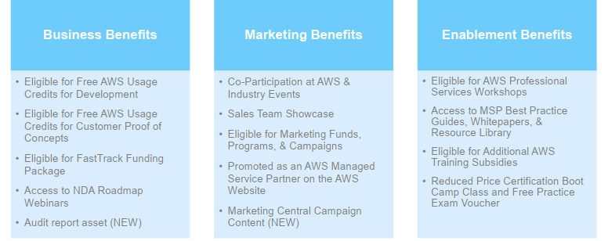

# How to become a certified MSP?

Becoming an MSP involves both a pre-audit assessment and an on-site audit. Depending on the partner’s business, the process can take more than 300+ hours of effort, requiring expertise from across the industry. MSPs complete a rigorous audit by an independent third party. Furthermore, to retain the badge, these partners need to continue to meet pre-requisites annually and complete a progress audit every year. As the cloud evolves, so will the expectations of these MSPs. MSP framework is built so that you can trust that the MSPs who’ve earned the badge are continuously working to remain true MSPs.

**Current Competencies**

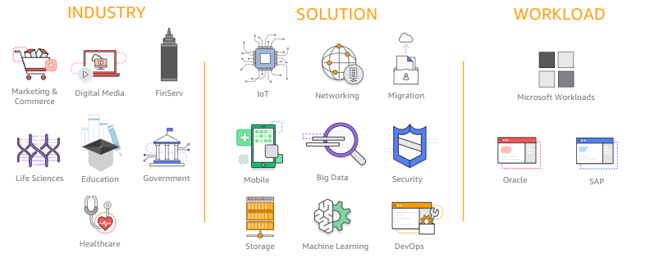

[**AWS MSP Partner Journey Roadmap**](https://d1.awsstatic.com/partner-network/Building_an_AWS_MSP_Practice_Journey_Roadmap_final.pdf)

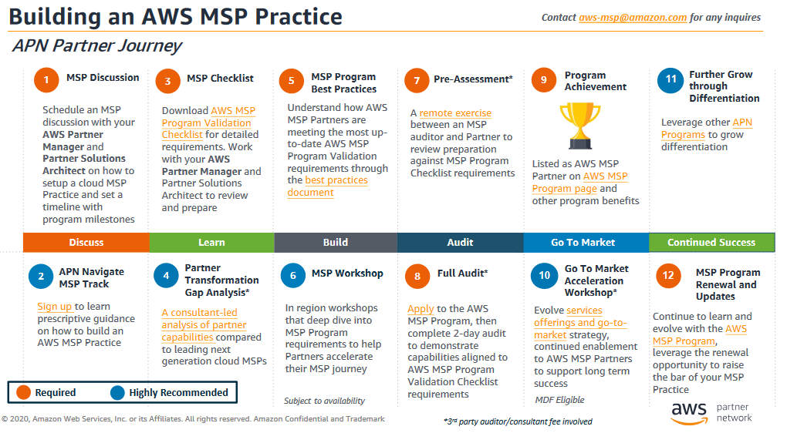

## **AWS MSP Partner Program prerequisites**

There are several prerequisites that you have to meet before scheduling an MSP Program Full Audit:

1. **APN membership**: The Partner must first become an Advanced or Premier Tier APN Consulting Partner, which comes with a $2,500 USD annual fee and a [list of its own requirements](https://aws.amazon.com/partners/consulting/" \t "_blank).
2. **Customer references**: Have at least four AWS customer references (with at least two that are publicly referenceable).
3. **Self-Assessment**: The Partner must complete a [Checklist Self-Assessment](https://partnercentral.awspartner.com/sfc/#version?selectedDocumentId=0690L000003ivJd) and email it to AWS.
4. **\*NEW\* Pre-Assessment**: After AWS reviews the self-assessment (which takes up to 10 business days), AWS will connect you with a third-party auditing firm that will conduct the Pre-Assessment remotely.

## **AWS MSP Partner Program Full Audit**

After completing all of the prerequisites, AWS will schedule a two-day Full Audit of all of the items in the checklist. The audit can be held remotely or onsite, and costs $3,000 USD (plus applicable travel fees). Make sure to have experts from your organization attend who can speak in-depth about the requirements.

## **AWS MSP Partner Validation scoring**

A core component of the audit process is a scoring system where an MSP can lose 200 points for failing to demonstrate capabilities for mandatory requirements. Partners can also gain bonus points for demonstrating non-mandatory services and capabilities.

**Sample selection of the AWS Managed Service Provider Partner Program Validation Checklist:**

| **Business Practices** | | **Mandatory (subtract if doesn't meet capability)** | **Bonus (add if meets capability)** |
| --- | --- | --- | --- |
| 1.1 Company Overview | APN Partner has a company overview presentation to set the stage... | - 200 |  |
| 1.2 Next Generation Managed Service Evangelism | APN Partner educates and evangelizes how managed services are different in an AWS environment... |  | + 40 |
| 1.3 Next Generation Managed Services Offering | APN Partner must have a public web presence that describes their AWS managed service practice... |  | + 20 |
| 2.1 Financial Health | APN Partner regularly assesses the financial health of its business through... | - 200 |  |

**Getting started with MSP Partner Program**

* Step #1: Register and progress as APN Consulting Partner
* Step #2: Build practice and apply for Advanced tier status
* Step #3: Prepare for Validation
  + Perform self-assessment
  + Collect objective evidence and prepare for audit
* Step #4: Apply to Program in APN Portal
  + Update Partner Scorecard • Complete program application
  + Send self-assessment